World War One: 10 interpretations of who started WW1
12 February 2014

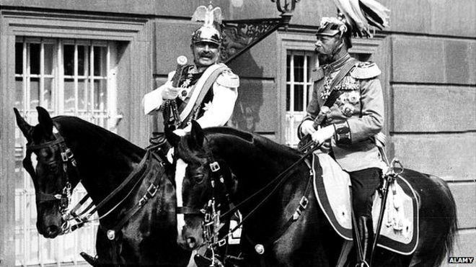 Royal cousins Wilhelm II and King George V went to war
As nations gear up to mark 100 years since the start of World War One, academic argument still rages over which country was to blame for the conflict.
Education Secretary for England Michael Gove's recent criticism of how the causes and consequences of the war are taught in schools has only stoked the debate further.
Here 10 leading historians give their opinion.

Sir Max Hastings - military historian
Germany
No one nation deserves all responsibility for the outbreak of war, but Germany seems to me to deserve most.
It alone had ower to halt the descent to disaster at any time in July 1914 by withdrawing its "blank cheque" which offered support to Austria for its invasion of Serbia.
I'm afraid I am unconvinced by the argument that Serbia was a rogue state which deserved its nemesis at Austria's hands. And I do not believe Russia wanted a European war in 1914 - its leaders knew that it would have been in a far stronger position to fight two years later, having completed its rearmament programme.
The question of whether Britain was obliged to join the European conflict which became inevitable by 1 August is almost a separate issue. In my own view neutrality was not a credible option because a Germany victorious on the continent would never afterwards have accommodated a Britain which still dominated the oceans and global financial system.

Sir Richard J Evans - Regius professor of history, University of Cambridge
Serbia
Serbia bore the greatest responsibility for the outbreak of WW1. Serbian nationalism and expansionism were profoundly disruptive forces and Serbian backing for the Black Hand terrorists was extraordinarily irresponsible. Austria-Hungary bore only slightly less responsibility for its panic over-reaction to the assassination of the heir to the Habsburg throne.
France encouraged Russia's aggressiveness towards Austria-Hungary and Germany encouraged Austrian intransigence. Britain failed to mediate as it had done in the previous Balkan crisis out of fear of Germany's European and global ambitions - a fear that was not entirely rational since Britain had clearly won the naval arms race by 1910.
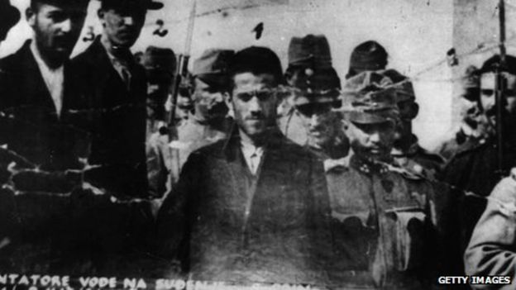
Bosnian Serb Gavrilo Princip assassinated Archduke Franz Ferdinand of Austria
The generally positive attitude of European statesmen towards war, based on notions of honour, expectations of a swift victory, and ideas of social Darwinism, was perhaps the most important conditioning factor. It is very important to look at the outbreak of the war in the round and to avoid reading back later developments - the German September Programme for example (an early statement of their war aims) - into the events of July-August 1914.

Dr Heather Jones - associate professor in international history, LSE
Austria-Hungary, Germany and Russia
A handful of bellicose political and military decision-makers in Austria-Hungary, Germany and Russia caused WW1.
Relatively common before 1914, assassinations of royal figures did not normally result in war. But Austria-Hungary's military hawks - principal culprits for the conflict - saw the Sarajevo assassination of the Austro-Hungarian Archduke Franz Ferdinand and his wife by a Bosnian Serb as an excuse to conquer and destroy Serbia, an unstable neighbour which sought to expand beyond its borders into Austro-Hungarian territories. Serbia, exhausted by the two Balkan wars of 1912-13 in which it had played a major role, did not want war in 1914.
Broader European war ensued because German political and military figures egged on Austria-Hungary, Germany's ally, to attack Serbia. This alarmed Russia, Serbia's supporter, which put its armies on a war footing before all options for peace had been fully exhausted.
This frightened Germany into pre-emptively declaring war on Russia and on Russia's ally France and launching a brutal invasion, partly via Belgium, thereby bringing in Britain, a defender of Belgian neutrality and supporter of France.

John Rohl - emeritus professor of history, University of Sussex
Austria-Hungary and Germany
WW1 did not break out by accident or because diplomacy failed. It broke out as the result of a conspiracy between the governments of imperial Germany and Austria-Hungary to bring about war, albeit in the hope that Britain would stay out.
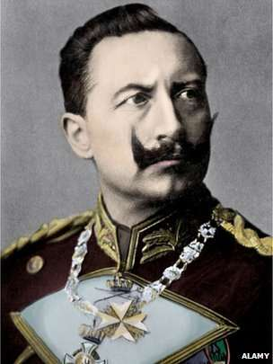
Kaiser Wilhelm II was eventually forced to abdicate
After 25 years of domination by Kaiser Wilhelm II with his angry, autocratic and militaristic personality, his belief in the clairvoyance of all crowned heads, his disdain for diplomats and his conviction that his Germanic God had predestined him to lead his country to greatness, the 20 or so men he had appointed to decide the policy of the Reich opted for war in 1914 in what they deemed to be favourable circumstances.
Germany's military and naval leaders, the predominant influence at court, shared a devil-may-care militarism that held war to be inevitable, time to be running out, and - like their Austrian counterparts - believed it would be better to go down fighting than to go on tolerating what they regarded as the humiliating status quo. In the spring of 1914, this small group of men in Berlin decided to make "the leap into the dark" which they knew their support for an Austrian attack on Serbia would almost certainly entail.
The fine-tuning of the crisis was left to the civilian chancellor Theobald von Bethmann Hollweg, whose primary aim was to subvert diplomatic intervention in order to begin the war under the most favourable conditions possible. In particular, he wanted to convince his own people that Germany was under attack and to keep Britain out of the conflict.

Gerhard Hirschfeld - professor of modern and contemporary history, University of Stuttgart
Austria-Hungary, Germany, Russia, France, Britain and Serbia
Long before the outbreak of hostilities Prussian-German conservative elites were convinced that a European war would help to fulfil Germany's ambitions for colonies and for military as well as political prestige in the world.
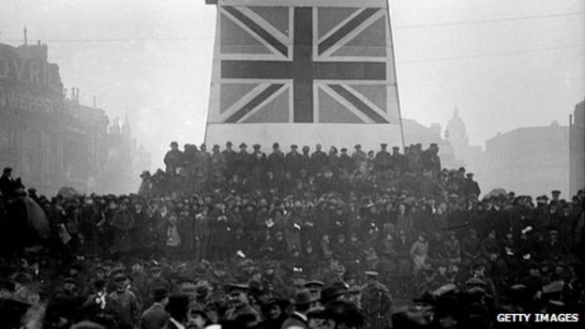
Britain could have done more to avert war argue some
The actual decision to go to war over a relatively minor international crisis like the Sarajevo murder, however, resulted from a fatal mixture of political misjudgement, fear of loss of prestige and stubborn commitments on all sides of a very complicated system of military and political alliances of European states.
In contrast to the historian Fritz Fischer who saw German war aims - in particular the infamous September Programme of 1914 with its far-reaching economic and territorial demands - at the core of the German government's decision to go to war, most historians nowadays dismiss this interpretation as being far too narrow. They tend to place German war aims, or incidentally all other belligerent nations' war aims, in the context of military events and political developments during the war.

Dr Annika Mombauer - The Open University
Austria-Hungary and Germany
Whole libraries have been filled with the riddle of 1914. Was the war an accident or design, inevitable or planned, caused by sleepwalkers or arsonists? To my mind the war was no accident and it could have been avoided in July 1914. In Vienna the government and military leaders wanted a war against Serbia. The immediate reaction to the murder of Franz Ferdinand on 28 June 1914 was to seek redress from Serbia, which was thought to have been behind the assassination plot and which had been threatening Austria-Hungary's standing in the Balkans for some time. Crucially, a diplomatic victory was considered worthless and "odious". At the beginning of July, Austria's decision-makers chose war.
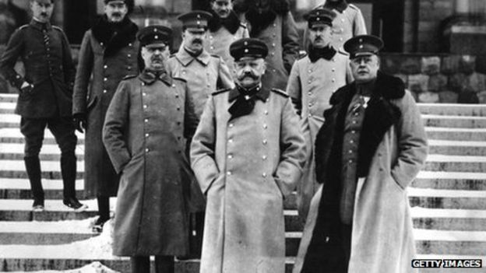
Germany recalled Hindenburg, centre, from retirement when war broke out
But in order to implement their war against Serbia they needed support from their main ally Germany. Without Germany, their decision to fight against Serbia could not have been implemented. The Berlin government issued a "blank cheque" to its ally, promising unconditional support and putting pressure on Vienna to seize this golden opportunity. Both governments knew it was almost certain that Russia would come to Serbia's aid and this would turn a local war into a European one, but they were willing to take this risk.
Germany's guarantee made it possible for Vienna to proceed with its plans - a "no" from Berlin would have stopped the crisis in its tracks. With some delay Vienna presented an ultimatum to Serbia on 23 July which was deliberately unacceptable. This was because Austria-Hungary was bent on a war and Germany encouraged it because the opportunity seemed perfect. Victory still seemed possible whereas in a few years' time Russia and France would have become invincible. Out of a mixture of desperation and over-confidence the decision-makers of Austria-Hungary and Germany unleashed a war to preserve and expand their empires. The war that ensued would be their downfall.

Sean McMeekin - assistant professor of history at Koc University, Istanbul
Austria-Hungary, Germany, Russia, France, Britain and Serbia
It is human nature to seek simple, satisfying answers, which is why the German war guilt thesis endures today.
Without Berlin's encouragement of a strong Austro-Hungarian line against Serbia after Sarajevo - the "blank cheque" - WW1 would clearly not have broken out. So Germany does bear responsibility.
But it is equally true that absent a terrorist plot launched in Belgrade the Germans and Austrians would not have faced this terrible choice. Civilian leaders in both Berlin and Vienna tried to "localise" conflict in the Balkans. It was Russia's decision - after Petersburg received its own "blank cheque" from Paris - to Europeanise the Austro-Serbian showdown which produced first a European and then - following Britain's entry - world conflagration. Russia, not Germany, mobilised first.
The resulting war, with France and Britain backing Serbia and Russia against two Central Powers, was Russia's desired outcome, not Germany's. Still, none of the powers can escape blame. All five Great Power belligerents, along with Serbia, unleashed Armageddon.

Prof Gary Sheffield - professor of war studies, University of Wolverhampton
Austria-Hungary and Germany
The war was started by the leaders of Germany and Austria-Hungary. Vienna seized the opportunity presented by the assassination of the archduke to attempt to destroy its Balkan rival Serbia. This was done in the full knowledge that Serbia's protector Russia was unlikely to stand by and this might lead to a general European war.
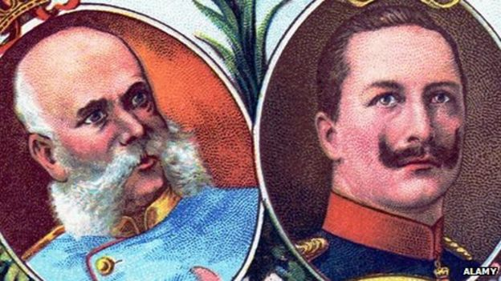
Austrian Emperor Franz Joseph I and Germany's Kaiser Wilhelm II were allies
Germany gave Austria unconditional support in its actions, again fully aware of the likely consequences. Germany sought to break up the French-Russian alliance and was fully prepared to take the risk that this would bring about a major war. Some in the German elite welcomed the prospect of beginning an expansionist war of conquest. The response of Russia, France and later Britain were reactive and defensive.
The best that can be said of German and Austrian leaders in the July crisis is that they took criminal risks with world peace.

Dr Catriona Pennell - senior lecturer in history, University of Exeter
Austria-Hungary and Germany
In my opinion, it is the political and diplomatic decision-makers in Germany and Austria-Hungary who must carry the burden of responsibility for expanding a localised Balkan conflict into a European and, eventually, global war. Germany, suffering from something of a "younger child" complex in the family of European empires, saw an opportunity to reconfigure the balance of power in their favour via an aggressive war of conquest.
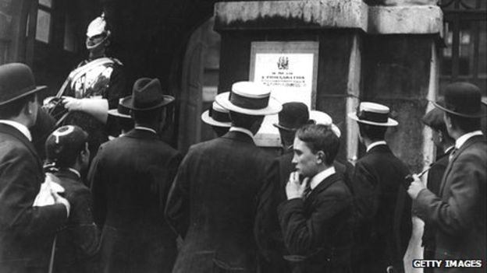
Britain declared war on Germany on 4 August 1914
On 5 July 1914 it issued the "blank cheque" of unconditional support to the crumbling Austro-Hungarian Empire (trying to reassert its dominance over the rebellious Serbia), despite the likelihood of this sparking war with Russia, an ally of France and Great Britain. However, Austria-Hungary's actions should not be ignored.
The ultimatum it issued to Serbia on 23 July was composed in such a way that its possibility of being accepted was near impossible. Serbia's rejection paved the way for Austria-Hungary to declare war on 28 July, thus beginning WW1.

David Stevenson - professor of international history, LSE
Germany
The largest share of responsibility lies with the German government. Germany's rulers made possible a Balkan war by urging Austria-Hungary to invade Serbia, well understanding that such a conflict might escalate. Without German backing it is unlikely that Austria-Hungary would have acted so drastically.
They also started wider European hostilities by sending ultimata to Russia and France, and by declaring war when those ultimata were rejected - indeed fabricating a pretext that French aircraft had bombed Nuremberg.
Finally, they violated international treaties by invading Luxemburg and Belgium knowing that the latter violation was virtually certain to bring in Britain. This is neither to deny that there were mitigating circumstances nor to contend that German responsibility was sole.
Serbia subjected Austria-Hungary to extraordinary provocation and two sides were needed for armed conflict. Although the Central Powers took the initiative, the Russian government, with French encouragement, was willing to respond.
In contrast, while Britain might have helped avert hostilities by clarifying its position earlier, this responsibility - even disregarding the domestic political obstacles to an alternative course - was passive rather than active.

