“What is the message of the cartoon?”
For these types of questions (1b – 2 marks), you can use the CID method:
Context: “At the time this source was produced….”
Interpretation: “The cartoonist’s point is that…” OR “One message of the source is…”
Describe: “This is clear from [certain details in the source]…”

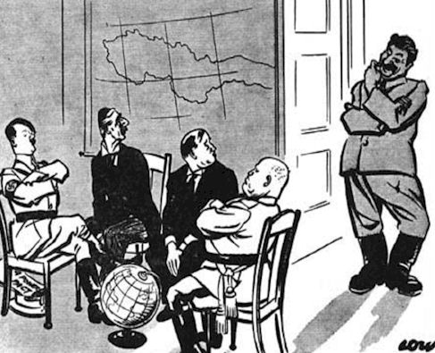
- 'What, no Chair for Me?' (1938)

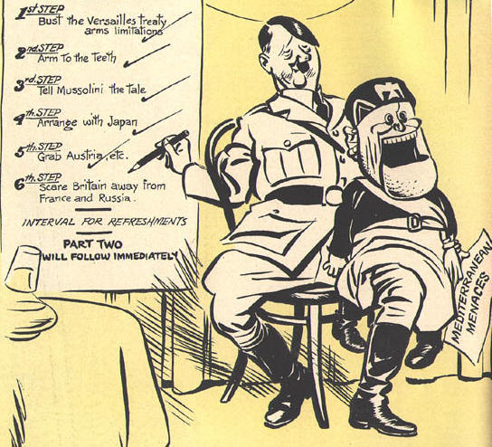
- 'Hitler and Mussolini' (1938)

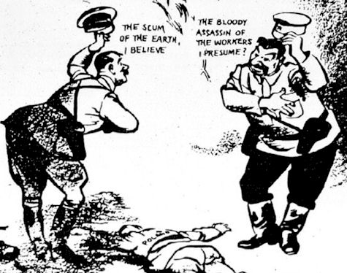
- “Hitler and Stalin” (August 1939)

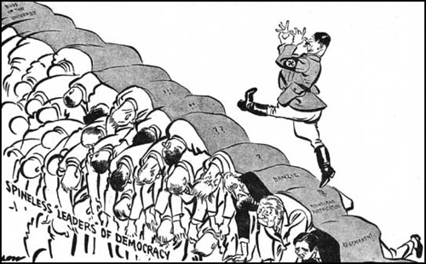
- “Spineless Leaders” (1938)

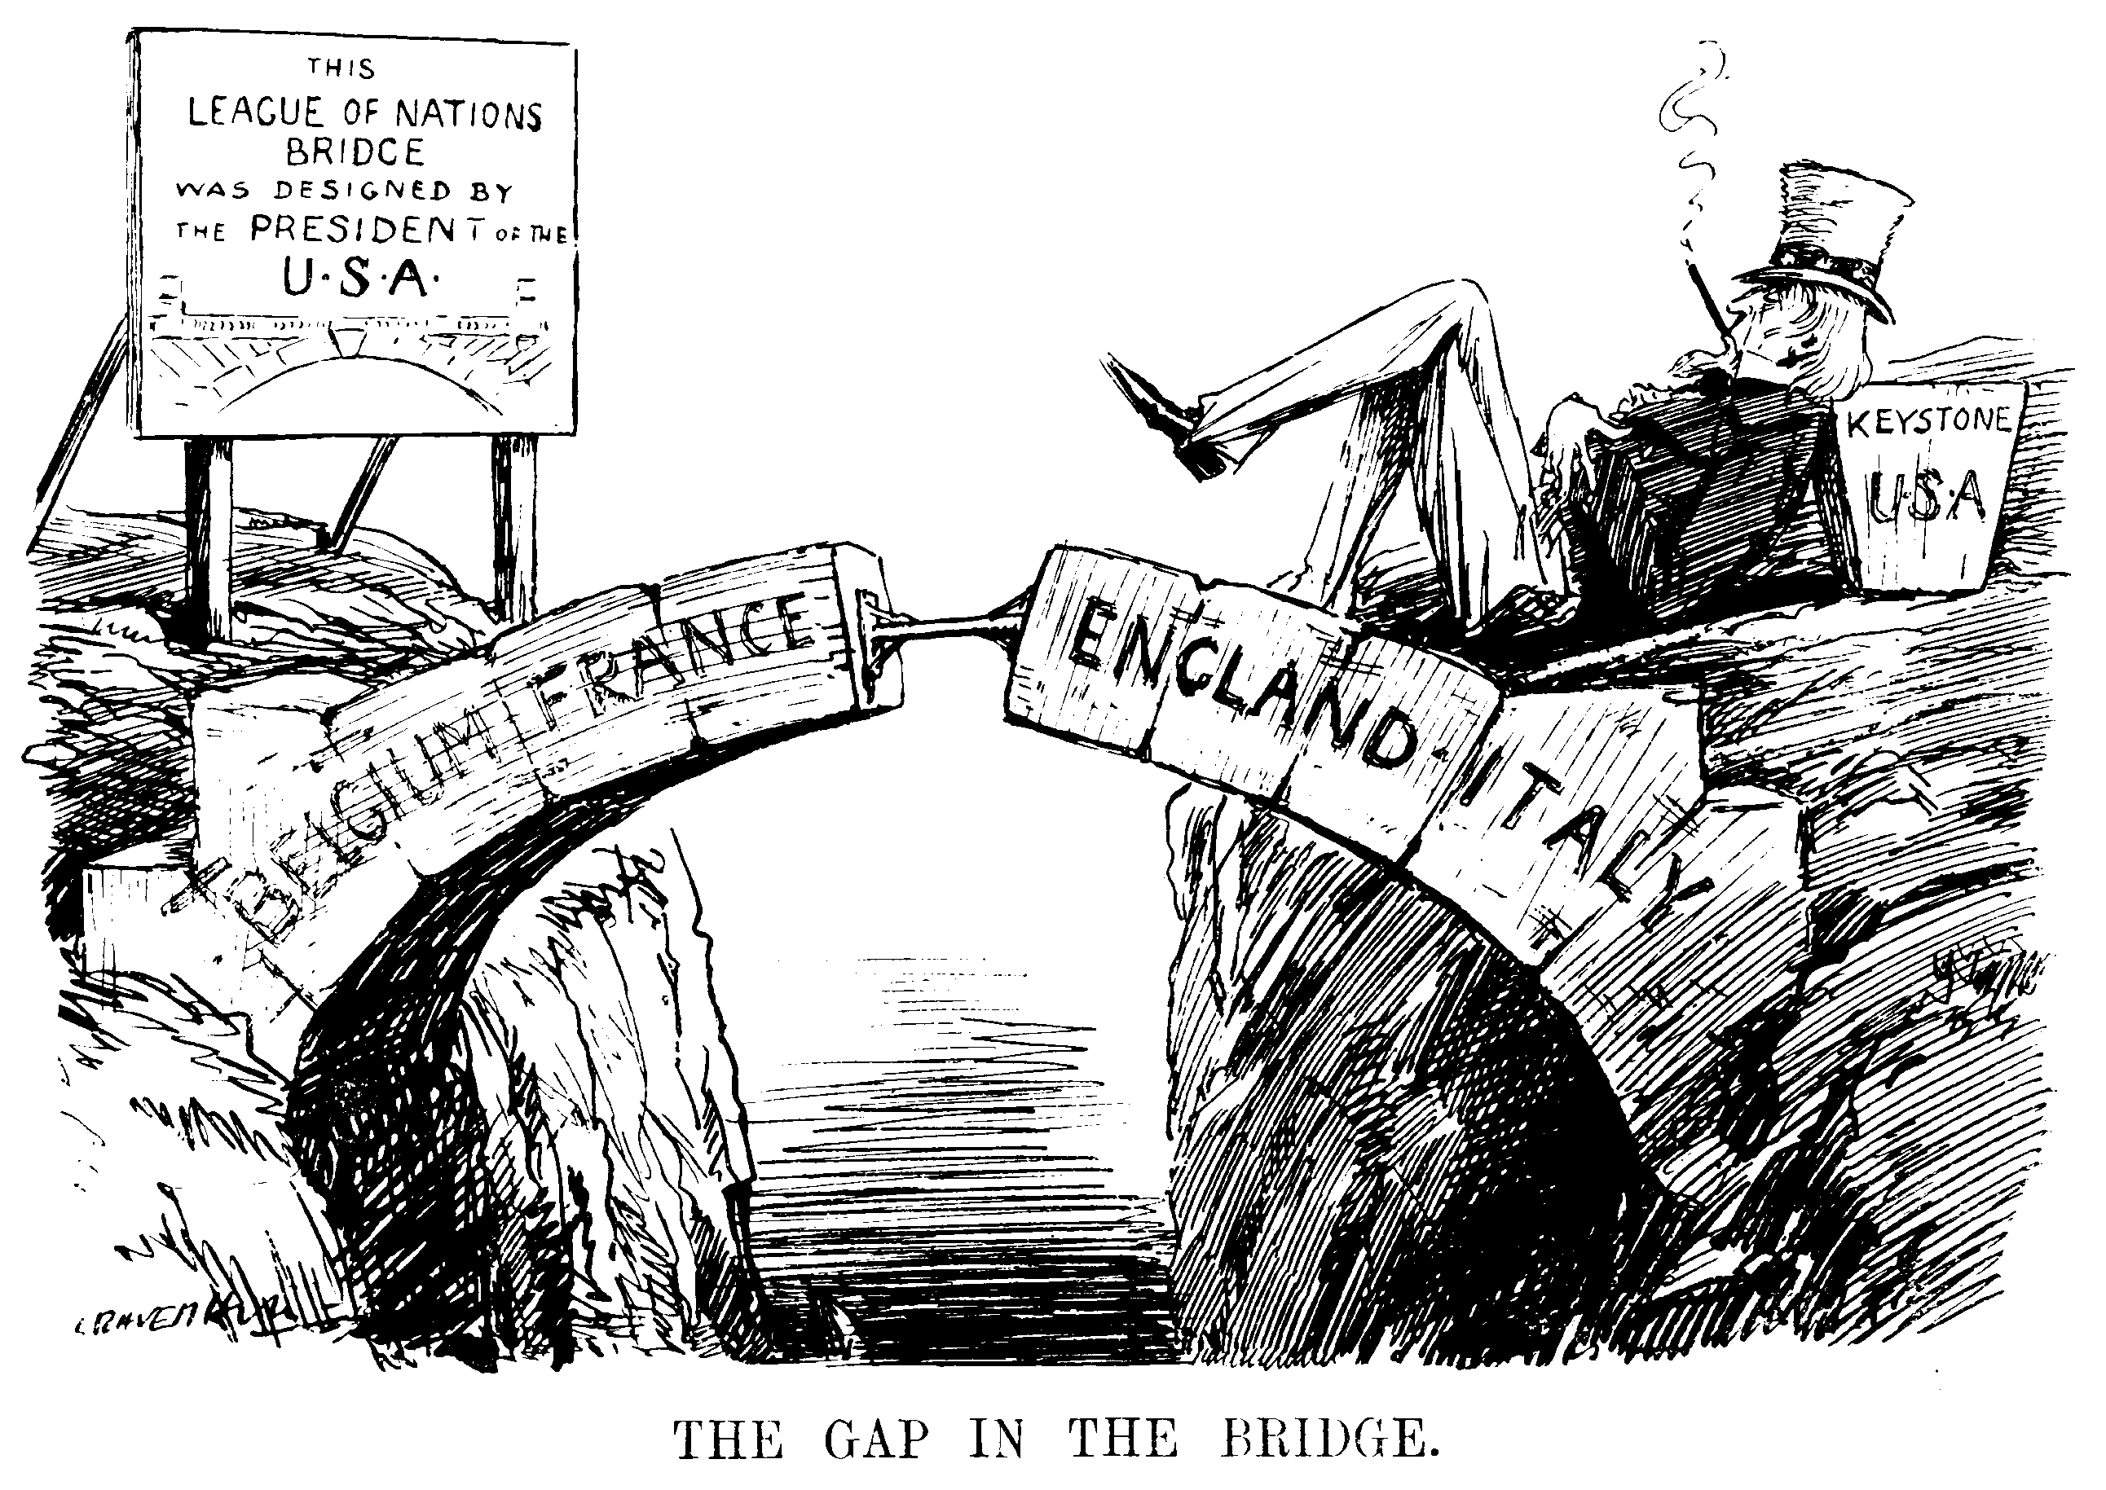
- A Gap in the Bridge, 1935

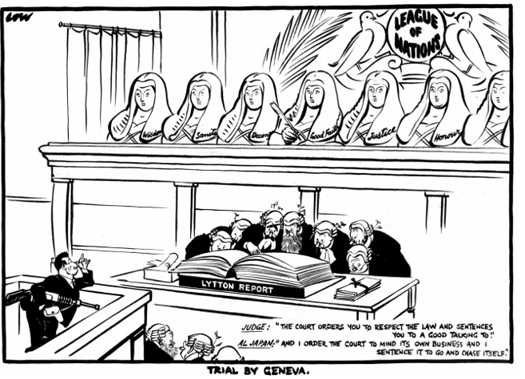
- “Trial by Geneva”
November 1932

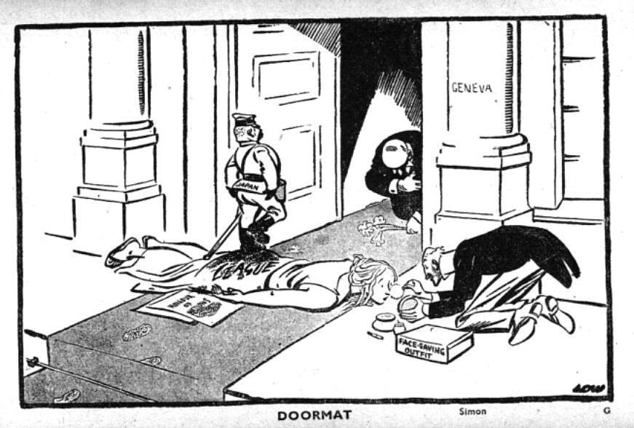
- “Doormat”, 1932

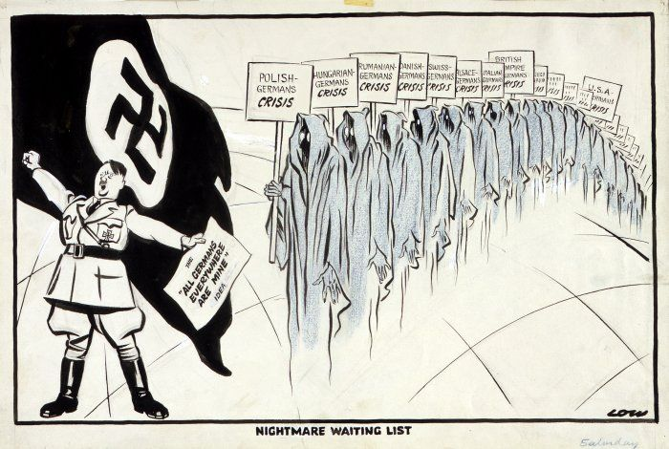
- “Nightmare Waiting List”, 1938

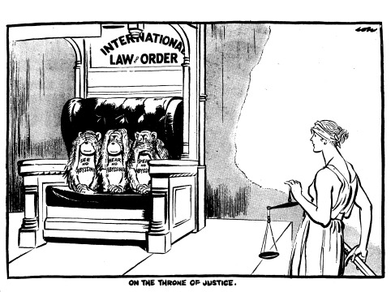
- “On the Throne of Justice”
Text: “See no Abyssinia, Hear no Abyssinia, Speak no Abyssinia”

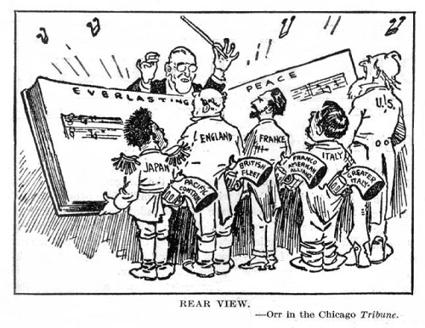
- “Rear View”, 1935

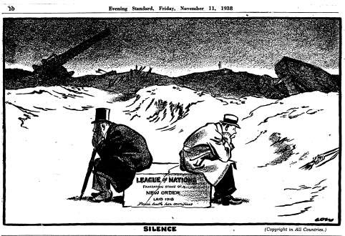
- “Silence”
This cartoon by the British cartoonist David Low appeared in the Evening Standard newspaper, 11 November 1938.
Two figures sit on a cracked stone, which carries the inscription: 'League of Nations. Foundation stone of a New Order, laid 1918. Peace hath her sacrifices.'

