German Foreign Policy, 1933-39
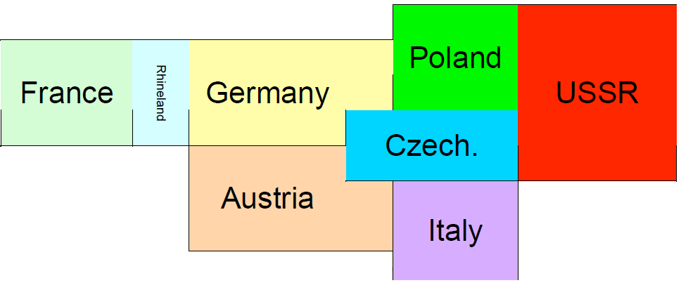
A topological map of Europe, 1930s
Instructions:
Complete the following table using the Oxford textbook and any addition readings or videos used in class.
When applicable, make notes on why Britain and France seemed to give in to German demands (appeasement)

Date / Event | What did Hitler do? Why? | What did other nations do? Why? | Hitler’s Tactical Skill | Luck! | Distractions  Or Differences  of other powers
Geneva Disarmament Conference, Oct 1933
Non-Aggression Pact with Poland, January 1934 |  |  | Hitler’s Tactical Skill | Luck! | Distractions  Or Differences  of other powers
Dolfuss Affair (attempted coup in Austria), July 1934
Anglo-German Naval Treaty, June 1935
Germany Remilitarizes the Rhineland, March 1936 |  |  | Hitler’s Tactical Skill | Luck! | Distractions  Or Differences  of other powers
Anschluss with Austria, March 1938
Czechoslovakia, 1938: The Sudetenland Crisis
Berchtesgaden, 15 Sept 1938
Godesberg, 22-23 Sept 1938
Munich, 29 Sept 1938
Invasion of Czechoslovakia, March 1939
Nazi-Soviet Pact, August 1939 |  |  | Hitler’s Tactical Skill | Luck! | Distractions  Or Differences  of other powers
Germany Invades Poland, Sept 1939 |  |  | x | x | x

