Author | Topic
deeks  Intermediate Member  Fraser Valley, BC  Canada  655 Posts | Posted - 09/05/2006 : 10:17 AM  Well in response to a post looking for Juan de Fuca trail 4 of us met up at MEC on Friday after work and headed for the ferry. We got to the trailhead only to meet Park Ranger who said we couldn't camp at the trail head but we got offered a visitors parking spot in the campground that worked for us.  I'll keep it brief because there is many a TR about the JDF trail. Basically we hit the trail head about 8am, enjoyed the trees & the ocean views. We pushed all the way through to Chin Beach for a 21km first day. We snagged one of the last spots above the high tide line (there were three guys in a pup tent that had to wait for high tide to pass at ~8:40pm so they could pitch their tent) there was whales, a beautiful sunset & ocean waves, just awesome. We also met a lot of friendly folk, many of whom we had seen earlier that day or would hike with the next day.  Sunday we packed up and headed on. More forest, many fresh signs of bears eating way too many berries. It was pleasent hiking through the shade of the trees. Had lunch at Sombrio beach and took the opportunity to dry out the tent fly I was carrying that was still dew soaked. The camping area hear was crazy, just tent after tent after tent. Passed some guys with surf boards who were offering rocks to the surf gods to bring some waves (I think they'd had more that a few) The hike was fairly uneventful from here, just forest, bridges & creeks, a few muddy sections.  This is where the trail lulls you into a false sense of security. I still don't know what happened but I stepped off one of the staircases and my ankle just rolled and went POP POP and was followed by a very sharp stabbing pain. There I am in the fetal position in agony, I pop off my pack and grab my med kit from the front pocket (always keep that where it is easy to get out) and dug out my advil and popped a few knowing that I was going to need them. Two of my companions and a third we had met on the trail were well ahead of me but I knew there was at least one person behind me so it would be OK. I tried to move my foot and I could so this was good after a little while I pulled my pack back on and pushed on. I have never been so thankful for my polls, couldn't have done it with out them. I was between KM 34 & 35 and I knew there was a trailhead at Parkinson Creek at KM 37 so I just started moving towards it. At some point the hiking companion behind me caught up and stayed with me the rest of the way. I will admit there was a couple times I fell and cried, it hurt OK! We got to the trailhead, I don't know how long it took and I said I couldn't go on, rather I would head to the highway and thumb a ride back. So I headed up the road to the highway. Turns out this is another 3km, just when I was close enough to hear the highway somebody drove up and offered me a ride. They were going to Port Renfrew so I just had them drop me at the highway. When I climbed in their vehicle I saw the clock and it was 5:15, I had hurt myself just after 2:30, that's a lot of limping.  Once at the highway I started thumbing. 4th vehicle by was the West Coast Trail Express heading to the Victoria bus depot. Someone was kind enough to jump off and haul my pack on and I was just thankful to be getting back to Victoria. From the bus depot it was 2 public busses later and I was in front of Royal Jubalee Hospital. As I'm dragging myself across the parking lot someone getting into their car looked and me and asked if I was hurt, I mean I was hobbling towards the ER entrance, and offered to drive me to the door. It was a kind offer but I declined, I had come this far I was walking (or something resembling it) through those doors under my own power.  So here I spent the next couple hours. They x-rayed it just in case. Fortunately it is just a bad sprain. I called some friends in Victoria I hadn't seen some time and and said hey, I'm in the ER and I missed the last ferry home any chance I can crash at your place. I told them they could toss me in the backyard if they like but they were kind enough to bump one of their kids out of their room so I could crash. Dr. told me to stay off my foot for a couple days at least and no hiking this month (hmmm he didn't say anything about climbing) So here I stay, my friends are going to ship me home tomorrow. In the mean time I'm making sure the couch doesn't fly away. It is good to have friends, actually they are kind of family, if your brother in law's cousin counts.  I'll post pictures, I know I've been delinquent with pictures and my TR's but the whole attaching your personal camera to company computers is grounds for dismissal policy makes it tough. I'm working on it.

outdoorjen  Starting Member  Victoria  35 Posts | Posted - 09/06/2006 : 12:06 AM  Well, as one of the three ahead of you, glad to hear that everything worked out somewhat. We had just sat down at Payzant when Nic came along and we were all feeling pretty bad about the news. Thank goodness Nic caught up to you and that the trailbus wasnt far behind. Make sure you take it easy and catch up with posting the pics! Ive worked my ankle myself pretty bad while hiking alone and Im also glad you had the poles. They would really help in that situation.

krylon  Starting Member  New West, BC  Canada  20 Posts | Posted - 09/08/2006 : 1:02 PM  Hey, it's Luke from the trip.  I'm glad you're all right, what a miracle Nic decided to push on and found you there! I had some knee trouble right in that same section, especially coming down those staircases. Sounds like you trooped it out.  I hope you heal up quick, and maybe we can hike again soon.

deeks  Intermediate Member  Fraser Valley, BC  Canada  655 Posts | Posted - 09/09/2006 : 12:46 PM  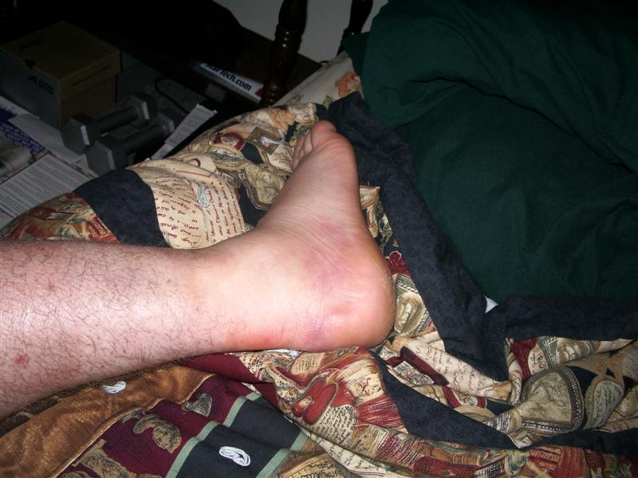  When I got home my roommate asked if I had taken a picture of my ankle yet so here it is. It happened on Sunday, this was taken Wednesday night so much of the swelling and bruising is gone but it still hurts!  Edited by - deeks on 09/09/2006 12:48 PM

deeks  Intermediate Member  Fraser Valley, BC  Canada  655 Posts | Posted - 09/15/2006 : 08:33 AM  I hurt myself about 2km before Parkinson Creek on Sunday.  My ankle is actually healing up well. I'm going through physio and apparently I have 2 grade 2 sprains and a grade 1 muscle tear but they are all in places that will heal up well. He worked at the joint for a while as we swapped hiking stories (I lucked out and got the physio that just came back from doing the Canadian great divide trail) and complemented me on my high pain tolerance. It is feeling much better and hopefully I'll be cleared to return to the trail, at least for easy stuff, real soon

- Individually, take your highlighter and highlight all the potential risks (objective and subjective) that you notice
- In pairs, compare what you noticed. For each highlighted risk, write a short explanation of how/why you identified it as a risk.

