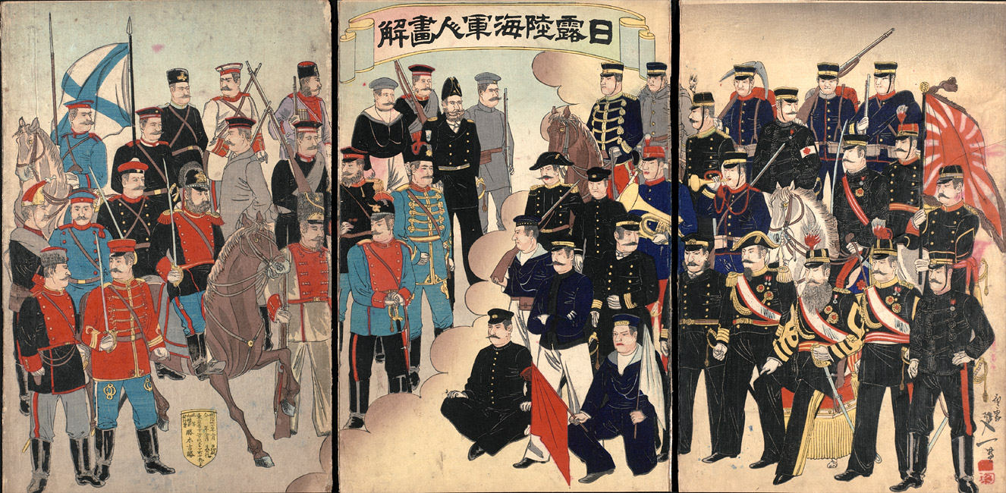
“Illustration of Russian and Japanese Army and Navy Officers” by Watanabe Nobukazu,
February 1904 [2000.087] Museum of Fine Arts, Boston

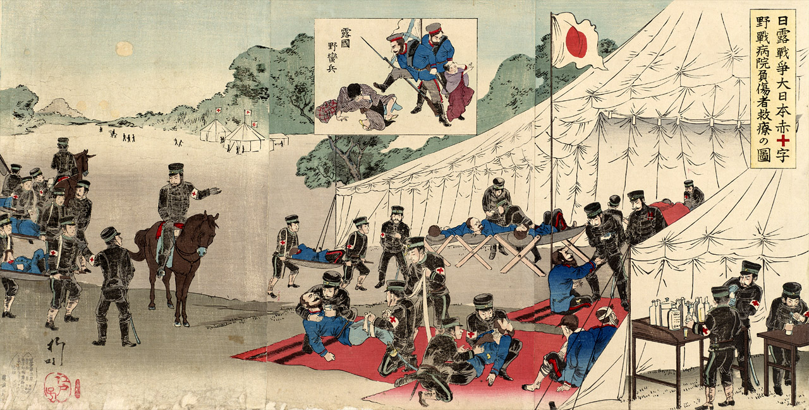
“Russo-Japanese War: Great Japan Red Cross Battlefield Hospital Treating Injured” by
Utagawa Kokunimasa, March 1904 [2000.367] Sharf Collection, Museum of Fine Arts, Boston

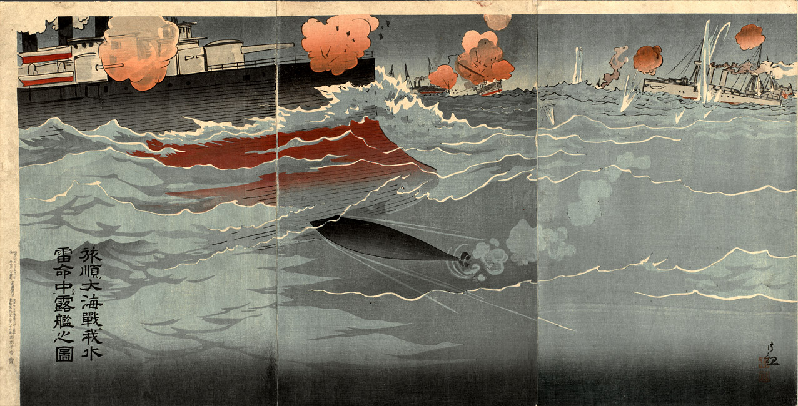
“Illustration of Our Torpedo Hitting Russian Ship at Great Naval Battle of Port Arthur”
by Kobayashi Kiyochika, February 1904 [2000.074] Sharf Collection, Museum of Fine Arts, Boston

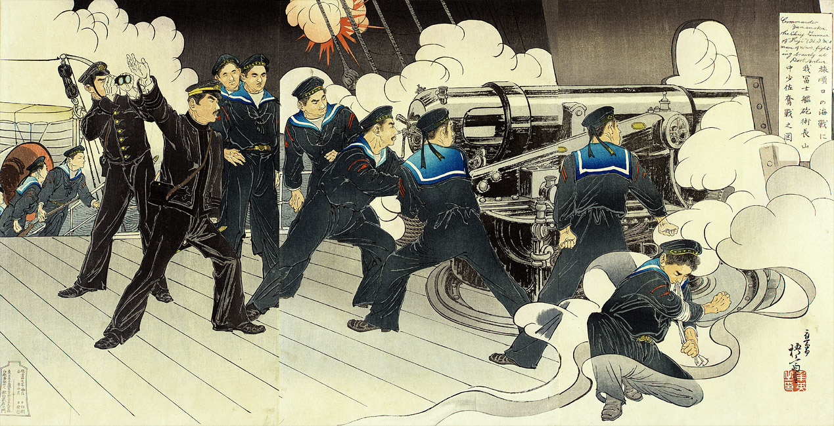
“Lieutenant Commander Yamanaka, Chief Gunner of Our Ship Fuji, Fights Fiercely in the Naval Battle at the
Entrance to Port Arthur” by Migita Toshihide, February 1904 [2000.75a-c] Museum of Fine Arts, Boston

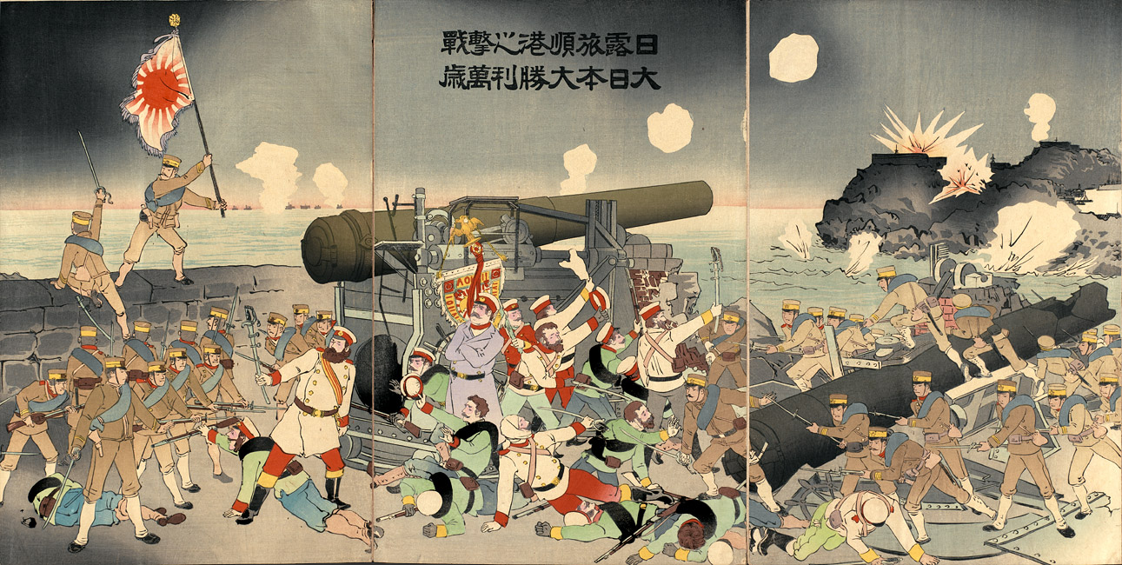
“The Battle of Japan and Russia at Port Arthur—Hurrah for Great Japan and Its Great
Victory,” artist unknown, 1905 [2000.356] Sharf Collection, Museum of Fine Arts, Boston

Excerpts from The Treaty of Portsmouth (1905)
ARTICLE I. There shall henceforth be peace and amity between their Majesties the Emperor of Japan and the Emperor of all the Russias, and between their respective States and subjects.

ARTICLE II. The Imperial Russian Government, acknowledging that Japan possesses in Korea paramount political, military and economical interests, engages neither to obstruct nor interfere with measures for guidance, protection and control which the Imperial Government of Japan may find necessary to take in Korea. …

ARTICLE III. Japan and Russia mutually engage:
First. — To evacuate completely and simultaneously Manchuria, except the territory affected by the lease of the Liaotung Peninsula, in conformity with the provisions of the additional article I annexed to this treaty, and,
Second. — To restore entirely and completely to the exclusive administration of China all portions of Manchuria now in occupation, or under the control of the Japanese or Russian troops, with the exception of the territory above mentioned. The Imperial Government of Russia declares that it has not in Manchuria any territorial advantages or preferential or exclusive concessions in the impairment of Chinese sovereignty, or inconsistent with the principle of equal opportunity.

ARTICLE IV. Japan and Russia reciprocally engage not to obstruct any general measures common to all countries which China may take for the development of the commerce or industry of Manchuria.

ARTICLE V. The Imperial Russian Government transfers and assigns to the Imperial Government of Japan, with the consent of the Government of China, the lease of Port Arthur, Talien and the adjacent territory and territorial waters, and all rights, privileges and concessions connected with or forming part of such lease, and it also transfers and assigns to the Imperial Government of Japan all public works and properties in the territory affected by the above‑mentioned lease. …

ARTICLE VI. The Imperial Russian Government engages to transfer and assign to the Imperial Government of Japan, without compensation and with the consent of the Chinese Government, the railway between Changchunfu and Kuanchangtsu and Port Arthur, and all the branches, together with all the rights, privileges and properties appertaining thereto in that region, as well as all the coal mines in said region belonging to or worked for the benefit of the railway. The two high contracting parties mutually engage to obtain the consent of the Government of China mentioned in the foregoing stipulation…

ARTICLE IX. The Imperial Russian Government cedes to the Imperial Government of Japan in perpetuity and full sovereignty the southern portion of the Island of Saghalin and all the islands adjacent thereto and the public works and properties thereon. The fiftieth degree of north latitude is adopted as the northern boundary of the ceded territory. The exact alignment of such territory shall be determined in accordance with the provisions of the additional article II annexed to this treaty. …
ARTICLE XI. Russia engages to arrange with Japan for granting to Japanese subjects rights of fishery

Question:
What did the Japanese gain under the terms of the Treaty of Portsmouth?

