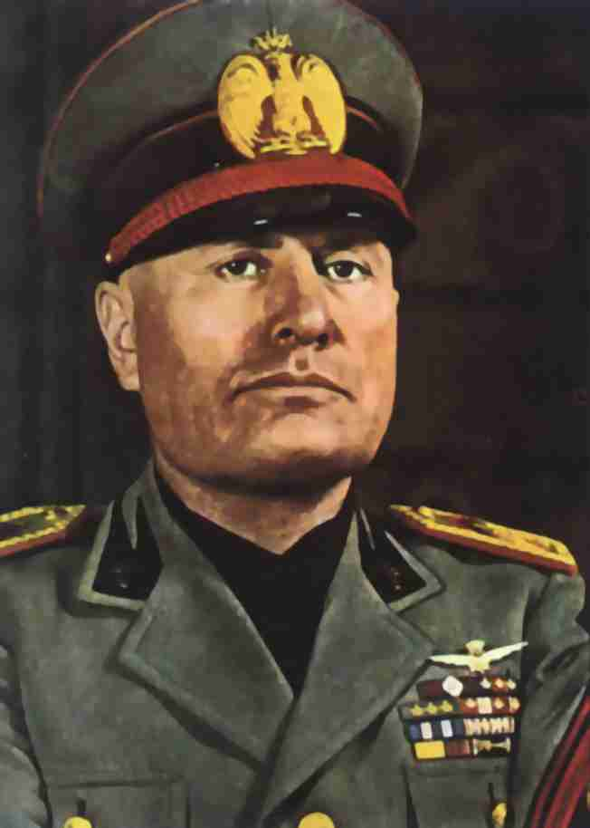
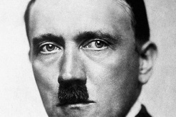
Steps to Establishing a Fascist Dictatorship

Name:______________________________

Complete the following table for Adolf Hitler

and Benito Mussolini. Add examples/evidence

from yourreadings and other course material.

Belief in extreme nationalism

“Glory to the State”

“Cultural / Racial Superiority”

Disdain for the importance of human rights

“The Nation is more important than the Individual”

Emphasis of military strength & obsession with national security

“Strength through Action”

Secret Police and Paramilitary organizations force compliance

Identification of enemies/scapegoats as a unifying cause

“They are the source of our problems”

The use of Mass Media to produce propaganda and create a Cult of Personality

“Going Viral”

Nicknames?

Religion and ruling elite tied together

“Church and State”

Elimination of political opponents and labour movements

“Anti-Communism”

“Anti-democracy”

Dissolution of Democratic institutions

“Emergency Powers” due to threat or insecurity?

Disdain and suppression of intellectuals and the arts

“Action over Thought”

