**Who is Responsible for the Second World War in Europe?**

*Each person in the class will draw a leader and country out of a box (Germany, Britain, France, USSR). Your task is as follows:*

1. To frame two prosecution questions against your particular country.

**Example:**

* Is it not fair to say that your invasion of Czechoslovakia in March 1939 was utterly unjustifiable?(against Germany)

1. For each question, have evidence to back up your point.
2. Then (you guessed it), you will once again draw a country out of a hat. This time, you will need to defend your country against the prosecution’s questions.

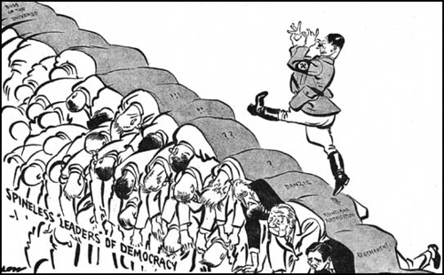

|  |  |  |
| --- | --- | --- |
| **Country** | **Guilty! Questions** | **Not Guilty! Responses** |
| **Germany**    *Hitler* |  |  |
| **Britain**    *Chamberlain* |  |  |
| **France**    *Daladier* |  |  |
| **USSR**    *Joseph Stalin* |  |  |