Who was to blame for the First World War?

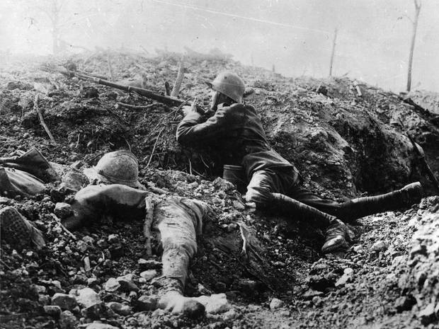

Independent.co.uk
Sean O’Grady
Tuesday 07 January 2014

1. Gavrilo Princip

As every schoolboy should know, it was the militant Serbian nationalist who assassinated Archduke Franz Ferdinand, the Austro-Hungarian prince whose killing led to his nation’s declaration of war on Serbia, which had a domino effect as other countries entering the conflict.

In his defence, it was an example of what we would nowadays term state-sponsored terrorism, as Princip and his friends were backed by elements in the Serbian government and army. Sooner or later they would have done something similar. Indeed the Belgrade government could be fairly criticised for not thinking through its policy, as it did little to benefit the country.
Princip missed the first time, but was hanging around a café when the Archduke’s chauffeur took a wrong turning, drove past again and offered a second chance to change the course of world history. So we might as well blame the Archduke’s chauffeur in an era before satnavs. For the record, his name was Leopold Lojka.

2. Sir Edward Grey

It was Viscount Grey who famously remarked: “The lamps are going out all over Europe, we shall not see them lit again in our lifetime.” This harmless Liberal politician, who might otherwise be better remembered as an ornithologist and for his definitive study of fly-fishing, has become a trendy scapegoat.

This is seemingly on the grounds that he should have made clear to the Germans that the British would fight – or that, had he more energetically pursued the idea of a great power conference on the eve of war, it might have been averted. His indolence and the indecision of the British Cabinet is therefore blamed for causing the war.

Appeasing imperial Germany may not have been very successful, however. When Neville Chamberlain pulled off precisely that sort of initiative at Munich in 1938, it at best bought the Allies time to rearm against Hitler. And in 1914 the advantage of time could easily have helped the Germans as much or more than the British. The lesson of history is that diplomacy cannot avert every conflict, and only has much chance of doing so between proper democracies.
As for telling the Germans that the British would stick by France, only a formal treaty would have done that – precisely the sort of action that would have provoked the Germans. It was certainly not a stratagem to keep Britain out of Europe’s quarrels.

3. Kaiser Wilhelm II

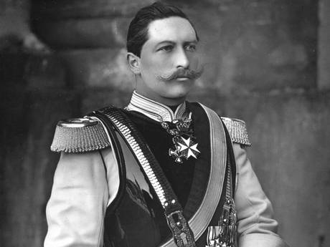
Bombastic, outspoken, and rather vain: Kaiser Wilhelm II
Many in Britain and France wanted to hang the German leader at the end of the Great War for his part in the conflict, and they almost succeeded.

Much amateur psychology has been deployed to explain the behaviour of the bombastic, outspoken and rather vain autocrat of Germany, especially the effect of on his personality of an arm withered from birth.

Then again, he was a fairly typical product of his time who wanted the newly united Germany to have a colonial empire in Africa and Asia that was a bit more like the vast British and French possessions, and to break out of a perceived encirclement by the British-French-Russian alliance. None of this could be described as being any sort of natural right, and its lack was no great hardship for this a thrusting, prosperous, teeming, modern industrial power.
Crucially, though, Wilhelm’s state was conducting war games from a very early stage. When conflict did come it was run on the Schlieffen Plan, updated since 1905, which dictated an invasion of Belgium to outflank the French and whatever contemptuous little army the British might muster.

When it came to it, the Kaiser and his advisers made two errors. First they gave Austria-Hungary pledges of support “whatever the circumstances” – and underwrote Austrian arrogance, a commodity not fully backed by reserves of Austrian military prowess. Second, they didn’t believe that the British would fight to uphold a treaty obligation given to Belgium in 1830 – a “piece of paper” as they called it. Like Hitler and General Galtieri later, this misjudgement was entirely their own fault.

4. Nationalism

If no one much cared about national interests, then of course the war would never have happened.

The truth of course, is that the story of the 20th century – and of the preceding century – was a story of nationalisms, big and small. From the pursuit of national interest and territorial expansion by the Great Powers to the then-emerging national consciousness from Ireland to Serbia to Finland and back again, it was a human instinct that drove clash after clash, crisis after crisis, incident after incident.

Mid-20th century it caught light across Asia and Africa, and for the past few decades has been fomenting dissent in South Sudan, Chechnya, former Yugoslavia, the Middle East, Quebec, Catalonia, Corsica , two halves of Belgium, and, yes, even Scotland today.
Nationalism is the obvious driver of war and terror, as well as peaceful divorces, but there was no antidote to it in 1914 – and, for all the benign influence of the UN, the EU, African Union and others, it remains as potent as ever.

5. Railway timetables

This was the idea famously put forward by the first of the telly historians, A J P Taylor, in the 1960s. (He could deliver a perfectly worded, argued and timed lecture live on TV to a peak time audience – those were the days.)

The argument runs that the war was the ultimate triumph of the steam age: the fat, efficient system of railways reached almost every hamlet and village across Europe and, like most technical innovations, could be adopted for martial use with relative ease.
The technology and the newly developed logistical ability to move hundreds of thousands of troops and horses, plus supplies, to an enemy border meant that once one state had mobilised its troops, its neighbour would have to do the same – because not to do so would offer the side that was already on the move an immediate strategic advantage, and possibly decisively so in a lightning war.

Your troops could be languishing in their barracks, still scrambling to get their kit ready, whilst the enemy rapes and pillages your people and captures your capital. In such circumstances, what would appear to a rational mind to be a mere precaution for war and a warning to the other side becomes de facto the first act of war.
The scope for a cataclysm by accident – with uncomfortable echoes during the Cold War, and Korea today – was obvious. As A J P Taylor put it: “It was an unexpected climax to the railway age.”

6. The arms race

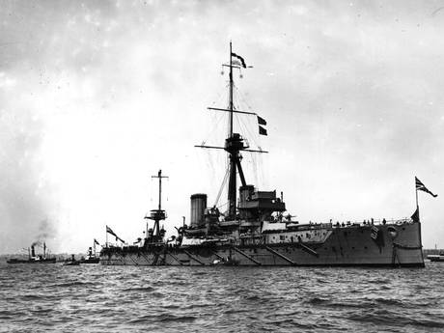
The Royal Navy battleship HMS Dreadnought
Another Cold War favourite, this is the Edwardian version of mutually assured destruction. It was famously described in an episode of Blackadder:

Blackadder: “You see, Baldrick, in order to prevent war in Europe, two superblocs developed: us, the French and the Russians on one side, and the Germans and Austro-Hungary on the other. The idea was to have two vast opposing armies, each acting as the other’s deterrent. That way there could never be a war.”

Baldrick: “But this is a sort of a war, isn’t it, sir?”

Blackadder: “Yes, that’s right. You see, there was a tiny flaw in the plan.”

George: “What was that, sir?”

Blackadder: “It was bollocks.”

Except, my dear Blackadder, that this episode was first screened in late 1989; within months the Cold War was over, the Soviet Union abolished itself and the West could be fairly said to have won it.

Given that no sane statesman in Europe in 1914 actually wanted a war – OK, with the odd exception – the main deterrent to it was indeed the existence of these great armies and armaments. In other words, had we not had an arms race, the war might easily have started sooner.

In so far as the British started this phase of the arms race with the construction of HMS Dreadnought and its sisters, the British could in this reading be said to have started the war.
The maritime, imperial power was understandably keen to protect its sea lanes, but also keen on mounting arbitrarily large margins of superiority over all possible rivals combined. So some blame can be laid there.

However, no one forced the Germans to try and match the British in naval power, and in two world wars their battleships spent most of their time doing nothing.
As in 1939, the British could have sat the Great War out, and profited greatly commercially – a view controversially put out by Niall Ferguson, and indeed the late Alan Clark, author of The Donkeys.

And yet that would necessarily have left Britain as a client state of Germany, not much more than a puppet, sub-contracted to run India and the like in the interests of a Greater German Reich. Whether you think that was worth fighting about is the real test of whose side you are on in this contemporary row.

