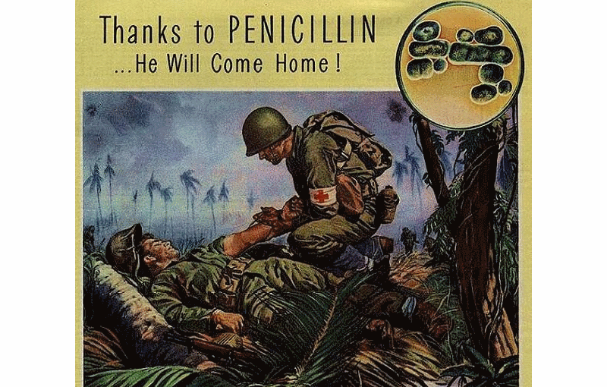
Penicillin
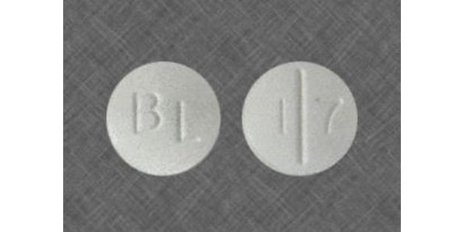
Originally, the discovery of the capabilities of the Penicillium Notatum mold on killing bacteria was made in 1869 by Ernest Duchesne and Sir Alexander Fleming made it popular later or in 1928 with his studies on the matter. However, it was not until 1939 when Dr. Howard Florey’s research was able to prove the effectiveness of penicillin without a shadow of a doubt and with the aid of Andrew J. Moyer he developed the most powerful antibacterial substance in the world. Needless to say, with all the wounded soldiers dying from simple infections, it was about time.

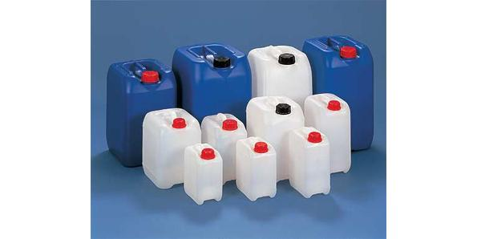
Jerrycans
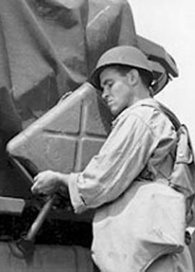
If you own a car, then you probably have a few motor oil and gasoline cans in your garage/trunk. However, the cans you utilize to transport fuel did not always look like that. In fact, before the Germans perfected the design of the “Jerrycan” (‘Jerry’ was a nickname for the Germans) by strengthening the structure with the cross shape, maximizing the contents of the can and adding the innovative handles that permitted soldiers to carry 2 of them in each hand, fuel containers used to be impractical and rudimentary. They predicted early on that blitzkrieg wouldn’t work very well without gas-on-the-go. Of course, the design was quickly reverse engineered by the allies.

Heavy Bombers and the pressurized cabin
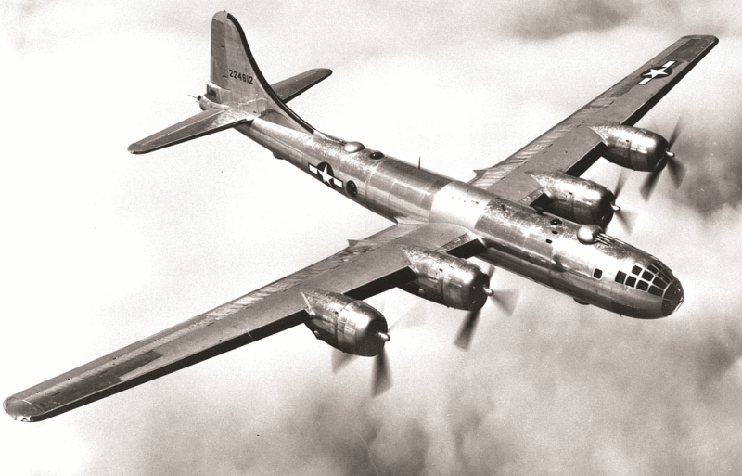
Heavy bombers – these are the machines that rained fire on their enemies and brought empires to their knees. The Germans had Junker and Dornier bombers, the Americans had B-17s and later, the B-29, nicknamed the “Flying Fortress”. These planes could fly long distances and drop their heavy payloads with increasing accuracy during the war. Heavy bombing was responsible for destroying Japanese and German industry, as well as entire cities in Asia and Europe.
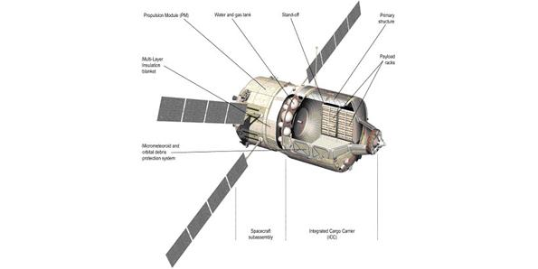
You have the US to thank for pressurized cabins, which practically revolutionized air transportation. It is necessary to point out that in the absence of similar pressure/temperature/oxygen condition, the pilot of the aircraft would not be able to fly at high altitudes. However, the solution utilized prior to pressurize cabins comprised of giving the pilot an oxygen mask, which needless to say, failed numerous times. A pilot could pass out from climbing in elevation too rapidly or just being at too high an elevation.
Synthetics: rubber, oil and other materials like nylon and plastic
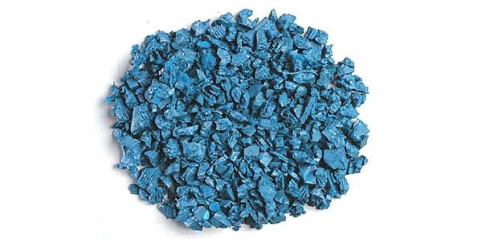
While synthetic oil was created by German scientists in order to account for the extreme shortage of its natural counterpart, synthetic rubber was invented in the US shortly after. It is necessary to mention that the polyethylene oils were utilized in powering the famous Luftwaffe air force throughout the entire World War 2. Synthetic rubber on the other hand was needed by the Allied Forces because the Axis controlled the vast majority of natural rubber suppliers; rubber was used in a multitude of war machines and was especially critical for tires. Since most silk came from Asia, the Allies used a new type of synthetic, nylon, for parachutes. Plastics became increasingly prevalent in all areas of technological construction, from the firing assemblies of firearms to IV and plasma bags (glass containers broke easily). Many soldiers would argue that the most important piece of plastic was the new latex condom – which, aside from preventing the syph, could waterproof the barrels of rifles in wet, dirty environments.
Radio communication and navigation
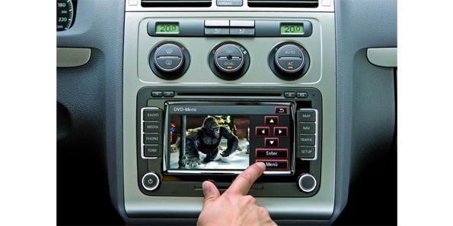
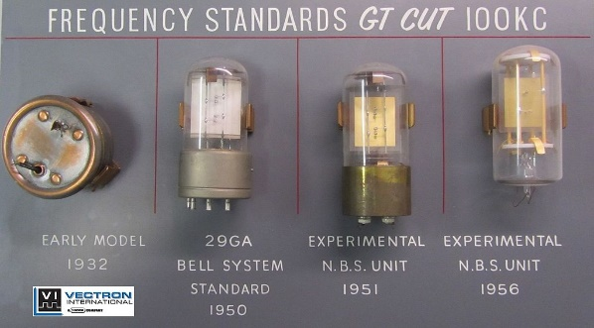
The quartz crystal oscillator utilizes the mechanical resonance from a vibrating crystal to create an electric signal with a very precise frequency. It is the source of radio frequencies and thus, the little gem behind the mass communication revolution that swept the 1930’s and 1940’s. Without the QCO, there would be no Fireside Chats – nor would soldiers be able to use short-wave radios to communicate with each other on the battlefield – essential for battlefield commanders, especially in the German armoured divisions executing blitzkrieg.
Before the invention of the Gee-H, Oboe and GEE neither of the forces was able to accurately direct their aircrafts in effective blind bombing runs. In addition, although flying these huge bombing ships was always incredibly difficult, landing them safely was even harder.

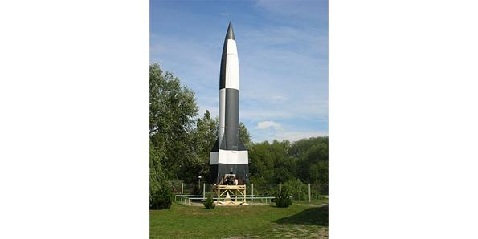
Rocketry
During the Second World War, the Germans developed two fearsome rocket weapons. While the original V-1 rocket was an extremely clumsy and inaccurate weapon that was easily countered by the Allies, the V-2 version is considered one of the deadliest ballistic missiles of all times. However, the technological principles behind the V-2 were also used in launching the very first satellites into orbit, namely the R7 and the Mercury Redstone. Furthermore, the 1930’s and 40’s saw the advancement of hydrogen peroxide as a propellant, making it the forerunner to the modern fuel cell. At the time, condensed H2O2 was particularly used to propel submarine torpedoes.

Radar and Sonar
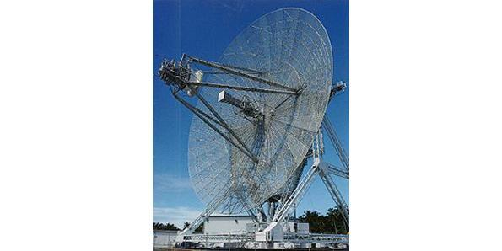
While the original plan for radio waves was to create a device that could concentrate them into powerful blasts (the presumed death ray machine), things took a different turn for this technology. The basis of the radio wave tech can be found back in 1886, but an actual demonstration of a working RADAR system capable of bouncing the radio signal off objects in order to determine their position was made much later on, in 1935 by Arnold F Wilkins. Radar was a major strategic advantage for the British during the Battle of Britain, and the development of Sonar technology (essentially using radar underwater) helped defend Allied shipping convoys against the U-boat threat as they crossed the Atlantic. It should be noted that the magnetron, the device behind the use of radar, also gives us the modern microwave (both are based on the stream of electrons in a magnetic field).

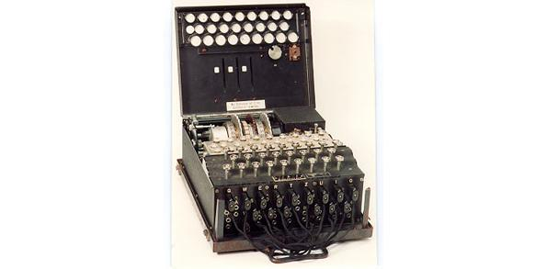
Enigma and the original computers
Two coding and decoding machines stand at the foundation of the modern day computer, namely the Enigma and the Lorentz machines. The role of these gadgets was to encode and respectively decode the traffic, which comprised mainly of communications between the German high command and the air, ground and naval forces dispatched. It is necessary to point out that while Enigma was based on a brilliant encryption system, there are more similarities between the Lorentz machines and computers nowadays. Cracking German and Japanese codes were of critical importance during the Second World War. As well, IBM’s early punch-card type computer played a key role in helping the Nazis organize their concentration camp system across German-controlled Europe.

Long-range fighters and the jet engine
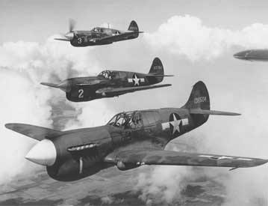
The British, the Germans, the Americans, the Japanese – all had developed impressive and terrifying fighter planes during the Second World War. Fighter planes were used to wrest control of the skies and gain air superiority so that heavy bombers would be protected as they made their bombing runs. As the war went on, the operational range of fighter planes increased dramatically. As their range increased, the mid-Atlantic gap (the area of the Atlantic that naval convoys were not protected by air support) shrunk, leading to the decimation of German U-boats.
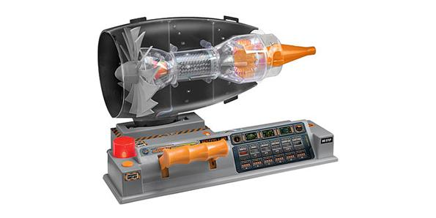
Ironically, the British scientist Sir Frank Whittle finalized the functioning prototype for jet engines long before the Germans, but the government showed limited interest in the invention and awarded him very low funds. This is the reason why the German army that poured massive funding and manpower into the development of this technology was able to reap the benefits sooner. The Messerschmitt ME 262 (fighter jet) and the Arado Ar 234 (bomber) were among the most feared weapons of the Axis, particularly the former one which was allegedly able to gun down 5 allied planes on average before being destroyed. The principle behind the original jet engines is still used for commercial flights nowadays.

Aircraft carriers
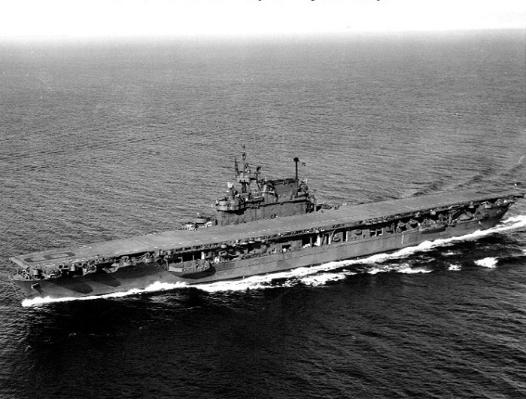
Aircraft carriers were of critical importance in the Pacific theatre of war, where airfields were scarce. Indeed, many great naval battles were fought entirely out at sea. Aircraft carriers would convoy with other warships so that when an enemy force was encountered it could launch fighter planes and torpedo bombers to attack the enemy force. A navy without air support was essentially a group of sitting ducks. Furthermore, the aircraft carrier enabled a mobile bomber force, essential in the Pacific war where the majority of lands were small, mountainous and jungle-covered islands. After the Japanese attack on Pearl Harbour, the United States retaliated with the Doolittle Raid, a bombing run on Japan’s industrial heartland. Neither of these events would have happened without carriers, and the war in the Pacific would have had a wildly different character if they were not developed.

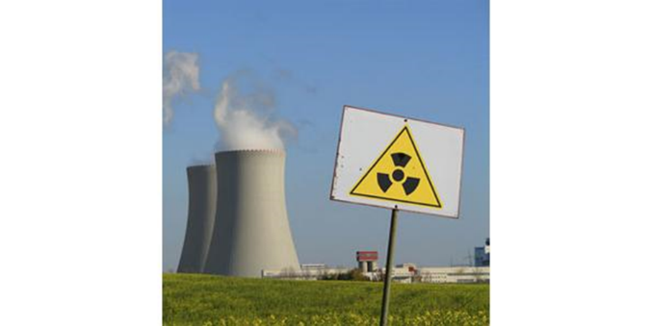
Nuclear power
When you think of nuclear power, the first thing that springs to mind is that it is a source of energy. However, nuclear power plants that we utilize to obtain electricity nowadays originated from the bombs dropped on the Japanese cities of Nagasaki and Hiroshima, namely the Fat Man and Little Boy. Although in theory the scientists of both sides were aware of the potential of the atom, the US managed to succeed in creating a weapon of mass destruction first through the Manhattan project. The debate on whether or not the world would be a better place without atomic power can go on forever, but the truth is that not only would we not benefit from this alternative energy source, but it is possible that WW2 would have lasted much longer and its end could differ radically. The month of August, 1945 holds onto the only two instances in which atomic bombs were dropped in an act of war – hundreds of thousands died in the initial blasts and hundreds of thousands more suffered and died afterward from radiation and birth defects.

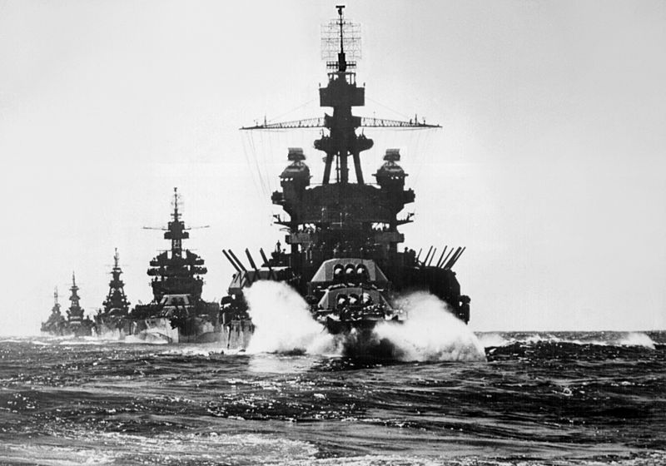
Battleships
The German battleship Schleswig-Holstein—an obsolete pre-dreadnought—fired the first shots of World War II with the bombardment of the Polish garrison at Westerplatte;^{[60]} and the final surrender of the Japanese Empire took place aboard a United States Navy battleship, USS Missouri. Between those two events, it had become clear that aircraft carriers were the new principal ships of the fleet and that battleships now performed a secondary role.
Battleships played a part in major engagements in Atlantic, Pacific and Mediterranean theaters; in the Atlantic, the Germans used their battleships as independent commerce raiders. However, the Battle of the Atlantic was fought mainly between destroyers and submarines, and most of the decisive fleet clashes of the Pacific war were determined by aircraft carriers.
At many of the early crucial battles of the Pacific, for instance Coral Sea and Midway, battleships were either absent or overshadowed as carriers launched wave after wave of planes into the attack at a range of hundreds of miles. As a counterpoint, battleships were crucial in performing shore bombardment in support of amphibious landings (particularly the Invasion of Normandy) and provided anti-aircraft defense as escort for the carriers.

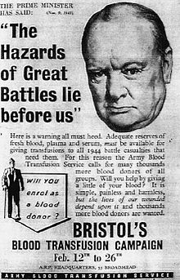
Blood transfusions & Tetanus Vaccine
It took centuries of study and experiments to discover the successful process of blood transfusion. Early attempts in the 17th century often used animal blood on humans (this almost always led to death) or had patients drink blood from healthy “donors” (often children). It was not until the first decade of the twentieth century when distinct blood types were discovered, and some of the first field blood transfusions were performed during the First World War.
During the interwar years much advancement was made. Anti-coagulants and refrigerants were developed, which allowed for long-term storage in blood banks. As well, research into blood plasma had developed to the point that in WW2 many field hospitals and sometimes even forward-deployed medics used plasma packets – a plastic package containing dried up plasma that one simply needed to mix with water. Blood plasma is the part of the blood that contains all the useful stuff – red blood cells (oxygen carrying), platelets (clotting cells), and thus the development of blood transfusion practice saved countless lives during this conflict. On the same note, the Tetanus vaccine was developed during this time and successfully prevented soldiers from contracting tetanus through open-wounds on the battlefield. It is with a sense of ambivalence that we recognize that many important medical advancements were brought about because of the horrible effects of war.

Submarines
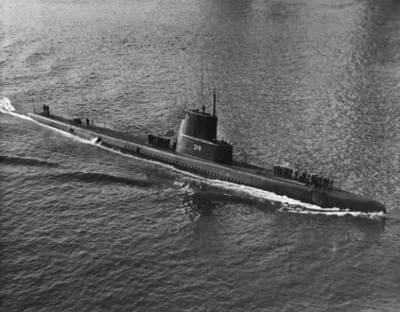
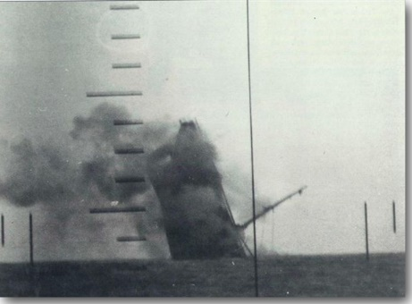
The submarine became a real threat during the Second World War in both theatres of operation. Germany used submarines to devastating effect in the Battle of the Atlantic, where it attempted to cut Britain's supply routes by sinking more merchant ships than Britain could replace. (Shipping was vital to supply Britain's population with food, industry with raw material, and armed forces with fuel and armaments.) The Germans, using new encrypted communications technology (enigma) used mass-attack tactics (commonly known as "wolfpack"). By the end of the war, almost 3,000 Allied ships (175 warships, 2,825 merchantmen) had been sunk by U-boats. While the Japanese had the greatest variety of submarine classes, they focused on attacking American fleet ships, which were faster, more maneuverable, and had far superior defensive systems than merchant shipping vessels. Submarines, though only about 2 percent of the U.S. Navy, destroyed over 30 percent of the Japanese Navy, including 8 aircraft carriers, 1 battleship and 11 cruisers. U.S. submarines also destroyed over 60 percent of the Japanese merchant fleet, crippling Japan's ability to supply its military forces and industrial war effort. Allied submarines in the Pacific War destroyed more Japanese shipping than all other weapons combined.

Sub-machine guns and Assault Rifles
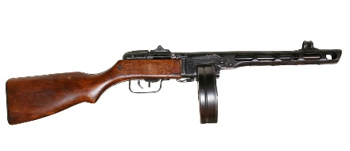
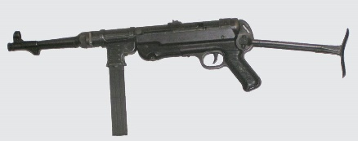
The submachine gun is a firearm more compact than a rifle and capable of firing fully automatic. While the Italians were the first to use a submachine gun in the field, the Finnish were the first to use them with a devastating effect: Finnish ski troops were known to surprise a column of Soviet troops, strafe them with submachine gun fire, then disappear on their skis. After this, the Soviets developed their own SMG (PPsh-41) based on the Finnish model, and throughout the war all the major nations produced their own staple SMGs. The Germans produced nearly a million MP40s, the Americans issued their Thompson M1A1 (think “Tommy Gun”), and the British produced nearly 4 million STEN guns. The Soviets, near the end of the war, would arm entire battalions with little other than the PPsh-41 - even with poorly trained troops they would create a devastating suppressive fire. In addition, WW2 saw the development of increasingly mobile machine guns and automatic rifles, which, combined with the widespread use of SMGs, made the individual soldier much more deadly and mobile in the Second World War.

Tanks
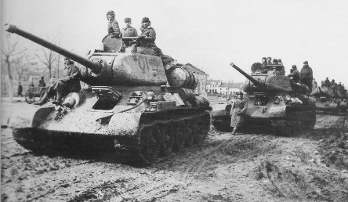
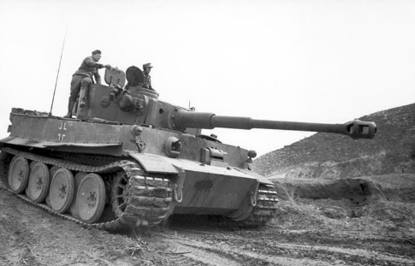
Tanks evolved from their First World War origins to become essential elements of the European theatre. While at first the Germans had a negligible technological advantage, their blitzkrieg tactics – using tanks as a spearhead force to encircle the enemy – led Poland to surrender in mere weeks, Belgium and Netherlands in a matter of days, and France in about six weeks. It was the blitzkrieg assault that brought German troops to the doors of Moscow and Leningrad with such speed that the Russians had to resort to scorched earth tactics (destroying their own villages, crops, and poisoning their water sources) in order to slow down the advance of German Panzer divisions. The war over North Africa was fought primarily with tanks, and they were critical in supporting infantry units all throughout the war. While the Germans fielded the some of the most powerful and effective tanks of the war (the Mark IV and the Tiger Tank), in the Eastern front their supremacy was overtaken by the Russian T-34. In the West, the Germans were no match for American industrial production, which produced an endless supply of Sherman tanks. While the rule of thumb was that it took five Shermans to knock out one Tiger, the Allies could afford this as the USA produced tens of thousands of tanks each year during the war – many times more than the Germans were capable of producing.

